
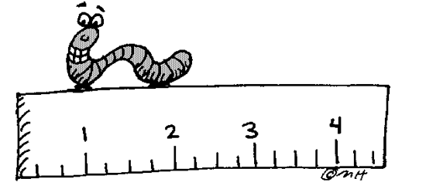 4th Grade Supply List
Eraser for whiteboard: You can also bring a rag, an old sock, a glove, etc.
3 Highlighters different colors
Colored pencil pack (any size)
2 boxes of Kleenex
Black Dry Erase Expo markers
Black Sharpies: 1 fine tip and 1 regular tip
Mrs. Wiggins Only
1 - 2 packages of No. 2 Ticonderoga pencils (sharpened please)
Earbuds- in a Ziplock baggie with student’s name on it
1 spiral notebook with 200 or more pages for math
Mrs. Thomas Only
1- 24 count box of Crayons
1- Composition Notebook
Mr. Clark Only
Binder: 1 to 1 ½ in. No bigger please. Please include 5 dividers with labels.
1 - 2 packages of No. 2 Ticonderoga pencils (sharpened please)

$Class donation of $20.00 appreciated: for things such as, art supplies, science experiment materials, social studies supplies, projects, learning tools, etc. Checks payable to Double Diamond Elementary. Thank you 😊
Optional: Water bottle- pop-top only, pocket dictionary with thesaurus, ruler: inches and centimeters
No pencil boxes please

